**STATS 295: Bayes-I**

**Ankoor Bhagat**

**UCI ID: 92963676**

***Homework # 2***

**1) Exercise 5.2**

WinBUGS Code:

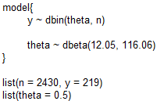

Stats:



Density:

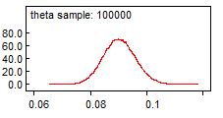

Example 5.1.1 results: Estimated median of the posterior distribution as 0.09 with 95% PI for θ of (0.08, 0.10), I got similar results after running the above code, the results are: Estimated median of the posterior distribution as **0.0922 with 95% PI for θ of (0.07952, 0.1017)**.

**Exercise 5.3**

Mode and 5th percentile of Beta(10, 1) distribution.

5th Percentile:

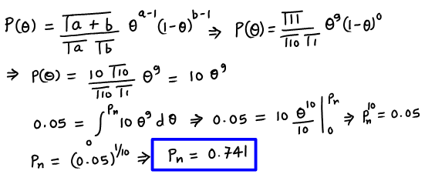

Mode:

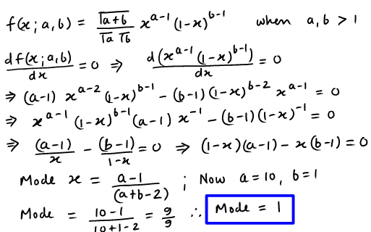

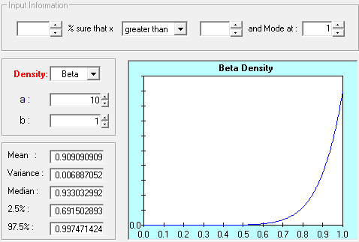

**Exercise 5.6**

1) Beta(a, b) prior for mode 0.75, and 5th percentile 0.6

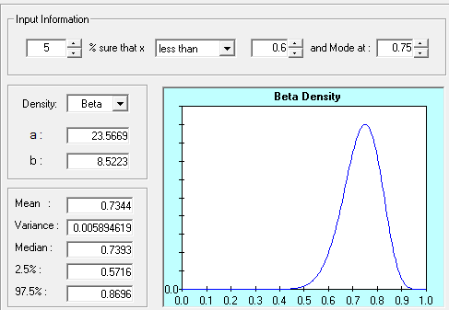

**Beta(23.5669, 8.5223)**

2) Beta(a, b) prior for mode 0.01, and 99th percentile 0.0

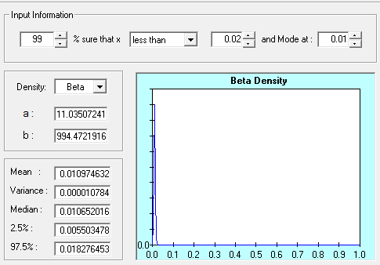

**Beta(11.035, 994.472)**

3) Beta(a, b) prior for mode 1, and 1st percentile 0.8

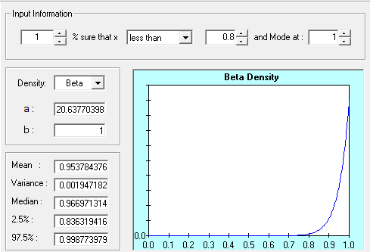

**Beta(20.64, 1)**

**Exercise 5.8**

Beta distributions for different choices of (a, b)

|  |  |  |  |  |
| --- | --- | --- | --- | --- |
| **X[i] ~ Beta(a[i], b[i])** | | **Y[i] ~ Beta(e[i], f[i])** | | **Bernoulli** |
| **a** | **b** | **e** | **f** | **d** |
| 1 | 0.4 | 0.3 | 1 | 0.1 |
| 1 | 30 | 10 | 1 | 0.3 |
| 36 | 0.2 | 0.6 | 20 | 0.5 |
| 28 | 1 | 1 | 10 | 0.7 |
| 0.7 | 1 | 1 | 0.5 | 0.9 |
| 0.4 | 39 | 12 | 0.3 | 0.5 |

Modified code:

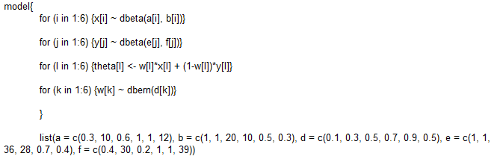

Result:

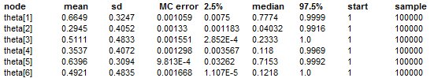

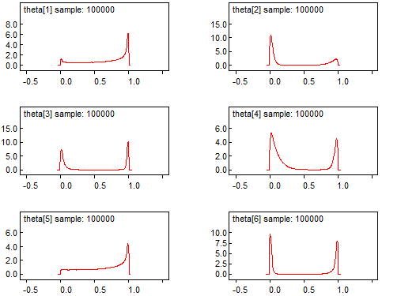

Original code:

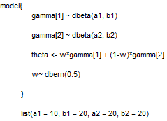

Result:



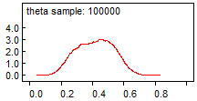

**Exercise 5.10**

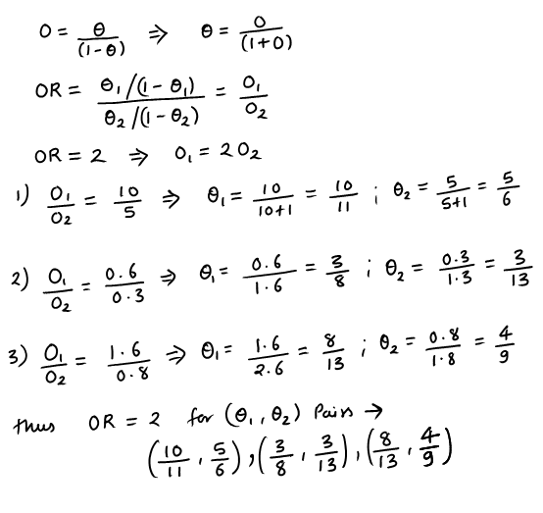

**Exercise 5.12**

1) Θ1 is 0.3, and experts are 95% sure that Θ1 is less than 0.6

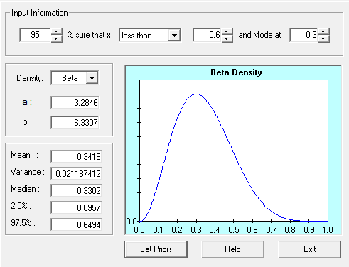

2) Θ1 is 0.5, and experts are 95% sure that Θ1 is less than 0.9

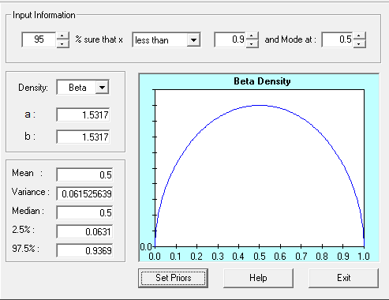

Code:

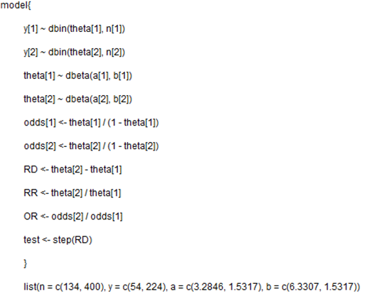

Result:

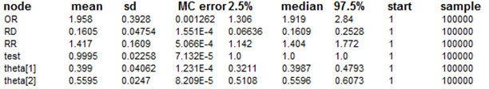

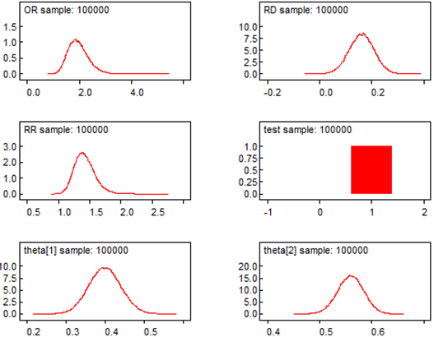

|  |  |  |  |  |  |  |  |  |  |  |
| --- | --- | --- | --- | --- | --- | --- | --- | --- | --- | --- |
|  | **WinBUGS: Posterior summaries (medfly)** | | | | | **Book: Posterior summaries (medfly)** | | | | |
| **Node** | **Mean** | **SD** | **2.50%** | **Median** | **97.50%** | **Mean** | **SD** | **2.50%** | **Median** | **97.50%** |
| OR | 1.958 | 0.393 | 1.306 | 1.919 | 2.840 | 1.915 | 0.393 | 1.266 | 1.873 | 2.802 |
| RD | 0.161 | 0.048 | 0.066 | 0.161 | 0.253 | 0.155 | 0.049 | 0.059 | 0.155 | 0.250 |
| RR | 1.417 | 0.161 | 1.142 | 1.404 | 1.772 | 1.400 | 0.162 | 1.124 | 1.384 | 1.750 |
| test | 1.000 | 0.023 | 1.000 | 1.000 | 1.000 | 0.999 | 0.031 | 1.000 | 1.000 | 1.000 |
| theta[1] | 0.399 | 0.041 | 0.321 | 0.399 | 0.479 | 0.405 | 0.042 | 0.324 | 0.404 | 0.487 |
| theta[2] | 0.560 | 0.025 | 0.511 | 0.560 | 0.607 | 0.560 | 0.025 | 0.511 | 0.560 | 0.607 |

Posterior summaries for medfly data (using theta[1] ~ Beta (3.2846, 6.3307) and theta[2] ~ Beta(1.5317, 1.5317) are similar to the posterior summaries for medfly data given in the text book.

**Exercise 5.15**

theta[2] ~ Beta(0.5, 0.5) and delta ~ N(0, 2)

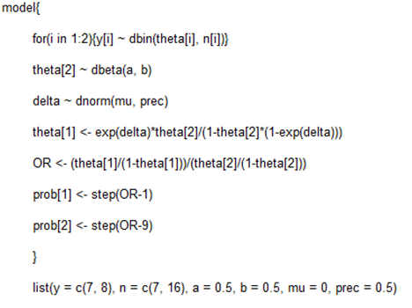

Result:

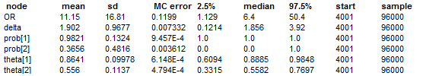

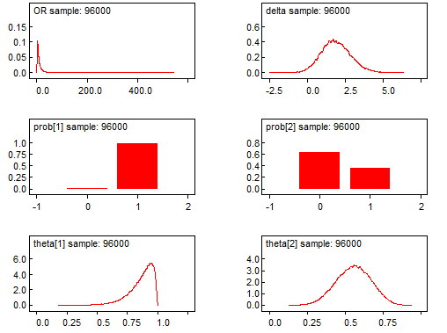

theta[2] ~ Beta(1, 1) and delta ~ U(log(0.02), log(50))

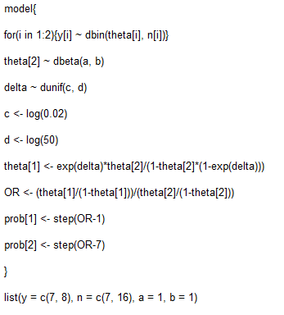

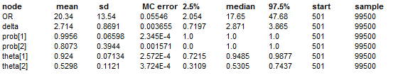

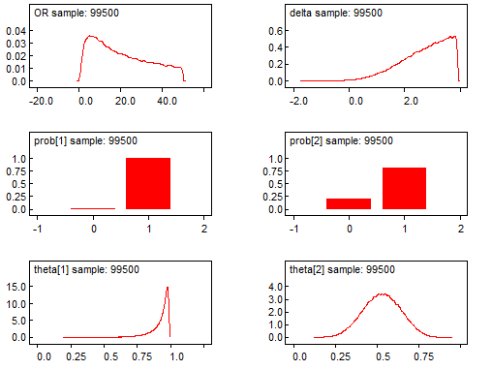

*Sensitivity Analysis*

1) theta[2] ~ Beta(1, 1) and delta ~ N(0, 2) => Using reference prior

Results:

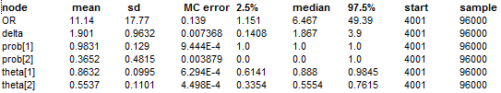

2) Prior that reflects skepticism about there is any effect.

theta[2] ~ Beta(0.5, 0.5) and let OR = 0.5, take mean of normal distribution to be ln(0.5) = -0.69. Assume that we are 95% sure that OR is at least, u = 8, thus ln(u=8) = 2.079 => 0.95 = Pr (OR <= u =8). Thus Pr(Z <= [ln(u) – ln (0.5)]/σ) = 0.95 => [ln(8) – ln (0.5)]/σ) = 1.645

* σ = 2.7725/1.645 = 1.685
* delta ~ N(0.5, (1.685)2) in WinBUGS delta ~ (-0.69, 0.352)

Result:

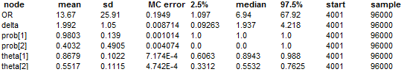

3) Prior that suggests any effect will be a positive one.

theta[2] ~ Beta(1, 1) and let OR = 4, take mean of normal distribution to be ln(4) = 1.38. Assume that we are 95% sure that OR is at least, u = 8, thus ln(u=8) = 2.079 => 0.95 = Pr (OR <= u =8). Thus Pr(Z <= [ln(u) – ln (4)]/σ) = 0.95 => [ln(8) – ln (4)]/σ) = 1.645

* σ = 0.69/1.645 = 0.42
* delta ~ N(4, (0.42)2) in WinBUGS delta ~ (1.38, 5.669)

Result:

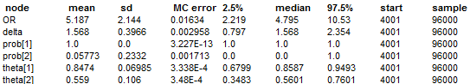

*Sensitivity analysis result*

|  |  |  |
| --- | --- | --- |
| **Priors** | **Code** | **OR (mean)** |
| theta[2] ~ Beta(0.5, 0.5) and delta ~ N(0, 2) | A | 11.15 |
| theta[2] ~ Beta(1, 1) and delta ~ U(log(0.02), log(50)) | B | 20.34 |
| theta[2] ~ Beta(1, 1) and delta ~ N(0, 2) | C | 11.14 |
| theta[2] ~ Beta(0.5, 0.5) and delta ~ N(0.5, (1.685)2) | D | 13.67 |
| theta[2] ~ Beta(1, 1) and delta ~ N(4, (0.42)2) | E | 5.187 |

**Exercise 5.16**

**(Part-A)**

Θ’1 have mode of 0.7 and 5th percentile = 0.5

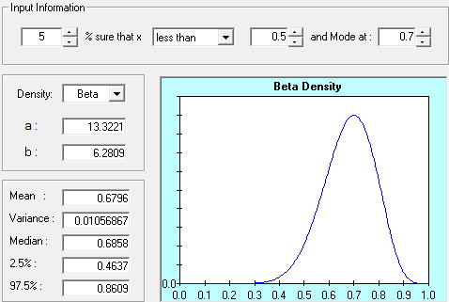

Θ’2 have mode of 0.3 and 95th percentile = 0.5

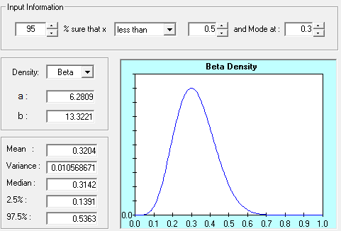

And gamma ~ Beta(2, 2)

Code:

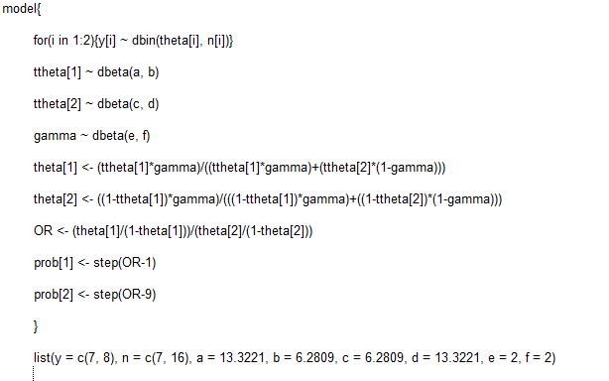

Result:

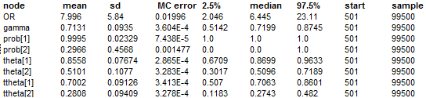

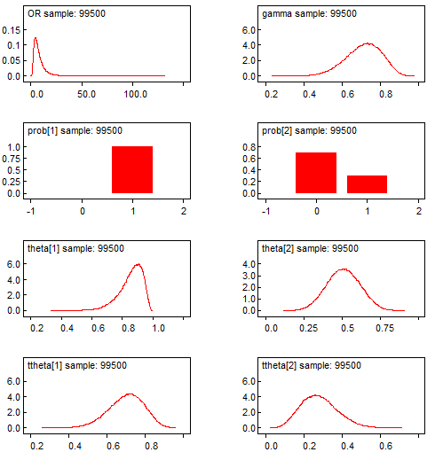

|  |  |  |  |  |  |  |
| --- | --- | --- | --- | --- | --- | --- |
|  | **Node** | **Mean** | **SD** | **2.50%** | **Median** | **97.50%** |
| Ex 5.14: U[0, 1] prior on theta[1] & theta[2] | OR | 136.200 | 13250.000 | 1.317 | 11.350 | 351.600 |
| theta[1] | 0.889 | 0.100 | 0.630 | 0.917 | 0.997 |
| theta[2] | 0.500 | 0.115 | 0.279 | 0.500 | 0.723 |
| Ex 5.15: N(0, 2) prior on delta, and Beta(0.5, 0.5) prior on theta[2] | OR | 11.150 | 16.810 | 1.129 | 6.400 | 50.400 |
| theta[1] | 0.864 | 0.100 | 0.609 | 0.889 | 0.985 |
| theta[2] | 0.556 | 0.114 | 0.332 | 0.558 | 0.770 |
| Ex 5.15: U(log(0.02), log(50)) prior on delta, and Beta(1, 1) prior on theta[2] | OR | 20.340 | 13.540 | 2.054 | 17.650 | 47.680 |
| theta[1] | 0.924 | 0.071 | 0.722 | 0.949 | 0.988 |
| theta[2] | 0.530 | 0.112 | 0.311 | 0.531 | 0.744 |
| Ex 5.16 (A): | OR | 7.996 | 5.840 | 2.046 | 6.445 | 23.110 |
| theta[1] | 0.856 | 0.077 | 0.671 | 0.870 | 0.963 |
| theta[2] | 0.510 | 0.108 | 0.302 | 0.510 | 0.719 |

The results of data analysis when priors on (theta[1] tilde, theta[2] tilde, and gamma) induces prior on (theta[1], and theta[2]) indicate that OR (7.996) has reduced considerably compared to OR values in Ex 5.14, Ex 5.15.

**(Part-B)**

Θ’1 have mode of 0.7 and 5th percentile = 0.6

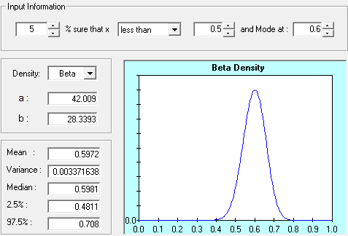

Θ’2 have mode of 0.3 and 95th percentile = 0.4

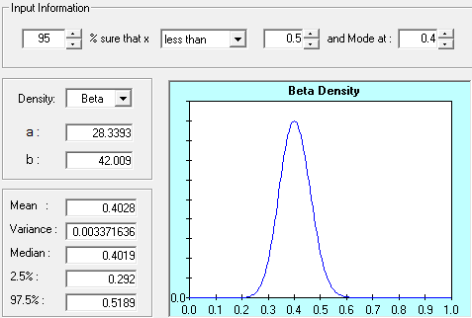

And gamma ~ Beta(2, 2)

Code:

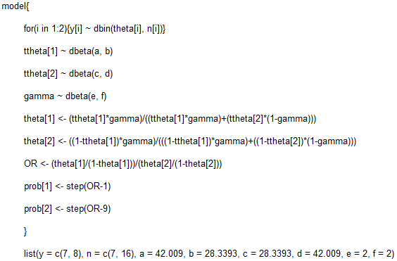

Result:

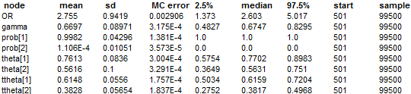

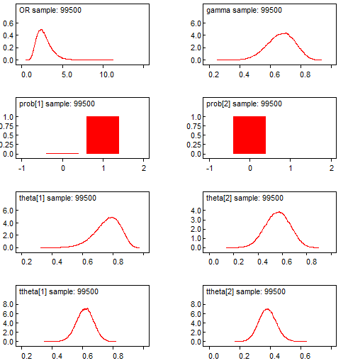

|  |  |  |  |  |  |  |
| --- | --- | --- | --- | --- | --- | --- |
|  | **Node** | **Mean** | **SD** | **2.50%** | **Median** | **97.50%** |
| Ex 5.14: U[0, 1] prior on theta[1] & theta[2] | OR | 136.200 | 13250.000 | 1.317 | 11.350 | 351.600 |
| theta[1] | 0.889 | 0.100 | 0.630 | 0.917 | 0.997 |
| theta[2] | 0.500 | 0.115 | 0.279 | 0.500 | 0.723 |
| Ex 5.15: N(0, 2) prior on delta, and Beta(0.5, 0.5) prior on theta[2] | OR | 11.150 | 16.810 | 1.129 | 6.400 | 50.400 |
| theta[1] | 0.864 | 0.100 | 0.609 | 0.889 | 0.985 |
| theta[2] | 0.556 | 0.114 | 0.332 | 0.558 | 0.770 |
| Ex 5.15: U(log(0.02), log(50)) prior on delta, and Beta(1, 1) prior on theta[2] | OR | 20.340 | 13.540 | 2.054 | 17.650 | 47.680 |
| theta[1] | 0.924 | 0.071 | 0.722 | 0.949 | 0.988 |
| theta[2] | 0.530 | 0.112 | 0.311 | 0.531 | 0.744 |
| Ex 5.16 (B): | OR | 2.755 | 0.942 | 1.373 | 2.603 | 5.017 |
| theta[1] | 0.761 | 0.084 | 0.575 | 0.770 | 0.898 |
| theta[2] | 0.562 | 0.100 | 0.365 | 0.563 | 0.751 |

The results of data analysis when priors on (theta[1] tilde, theta[2] tilde, and gamma) induces prior on (theta[1], and theta[2]) indicate that OR (2.755) has reduced considerably compared to OR values in Ex 5.14, Ex 5.15.

**Exercise 5.18**

**Part(A)** From previous exercise in which theta[2] ~ Beta(0.5, 0.5) and delta ~ N(0, 2), we get theta[2] posterior results as shown below:

|  |  |  |  |  |  |
| --- | --- | --- | --- | --- | --- |
| **Node** | **Mean** | **SD** | **2.50%** | **Median** | **97.50%** |
| theta[2] | 0.5537 | 0.1101 | 0.3354 | 0.5554 | 0.7615 |

Now using Beta Buster we get new prior =>

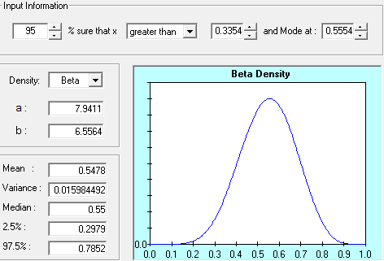

Theta[2] ~ Beta(7.9411, 6.5564)

Code:

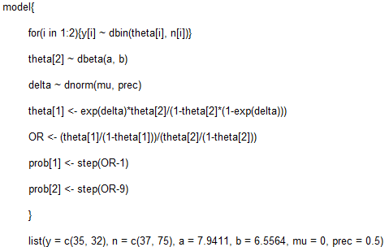

Result:

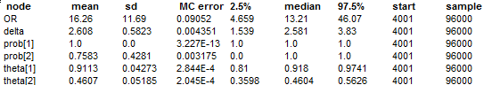

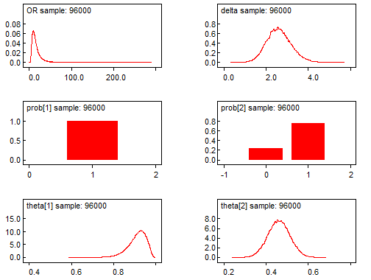

**Part(B)** *Sensitivity Analysis*

1) Prior that reflects skepticism about there is any effect.

theta[2] ~ Beta(7.9411, 6.5564) and let OR = 0.5, take mean of normal distribution to be ln(0.5) = -0.69. Assume that we are 95% sure that OR is at least, u = 8, thus ln(u=8) = 2.079 => 0.95 = Pr (OR <= u =8). Thus Pr(Z <= [ln(u) – ln (0.5)]/σ) = 0.95 => [ln(8) – ln (0.5)]/σ) = 1.645

* σ = 2.7725/1.645 = 1.685
* delta ~ N(0.5, (1.685)2) in WinBUGS delta ~ (-0.69, 0.352)

Result:

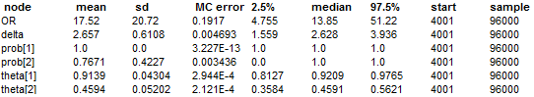

2) Prior that suggests any effect will be a positive one.

theta[2] ~ Beta(7.9411, 6.5564) and let OR = 4, take mean of normal distribution to be ln(4) = 1.38. Assume that we are 95% sure that OR is at least, u = 8, thus ln(u=8) = 2.079 => 0.95 = Pr (OR <= u =8). Thus Pr(Z <= [ln(u) – ln (4)]/σ) = 0.95 => [ln(8) – ln (4)]/σ) = 1.645

* σ = 0.69/1.645 = 0.42
* delta ~ N(4, (0.42)2) in WinBUGS delta ~ (1.38, 5.669)

Result:

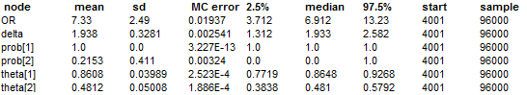

|  |  |  |
| --- | --- | --- |
| **Priors** | **Code** | **OR (mean)** |
| theta[2] ~ Beta(7.9411, 6.5564) and delta ~ N(0, 2) | A | 16.26 |
| theta[2] ~ Beta(7.9411, 6.5564) and delta ~ N(0.5, (1.685)2) | B | 17.52 |
| theta[2] ~ Beta(7.9411, 6.5564) and delta ~ N(4, (0.42)2) | C | 7.33 |